# Project Design Phase-II

**Data Flow Diagram & User Stories**

|  |  |
| --- | --- |
| Date | 26-06-2025 |
| Team ID | SWUID20250172439 |
| Project Name | Social Media App |
| Maximum Marks | 4 Marks |

**Data Flow Diagrams:**

A Data Flow Diagram (DFD) illustrates how data moves within the **Socialex** platform. It captures user interactions (e.g., profile updates, posts, chat), how information is processed, and how it flows through key components like the database, media storage, and real-time messaging.

# Key DFD Entities:

* Users (regular users)
* Admin
* Post Module
* Chat Module
* Profile Module
* Firebase Storage
* MongoDB Database

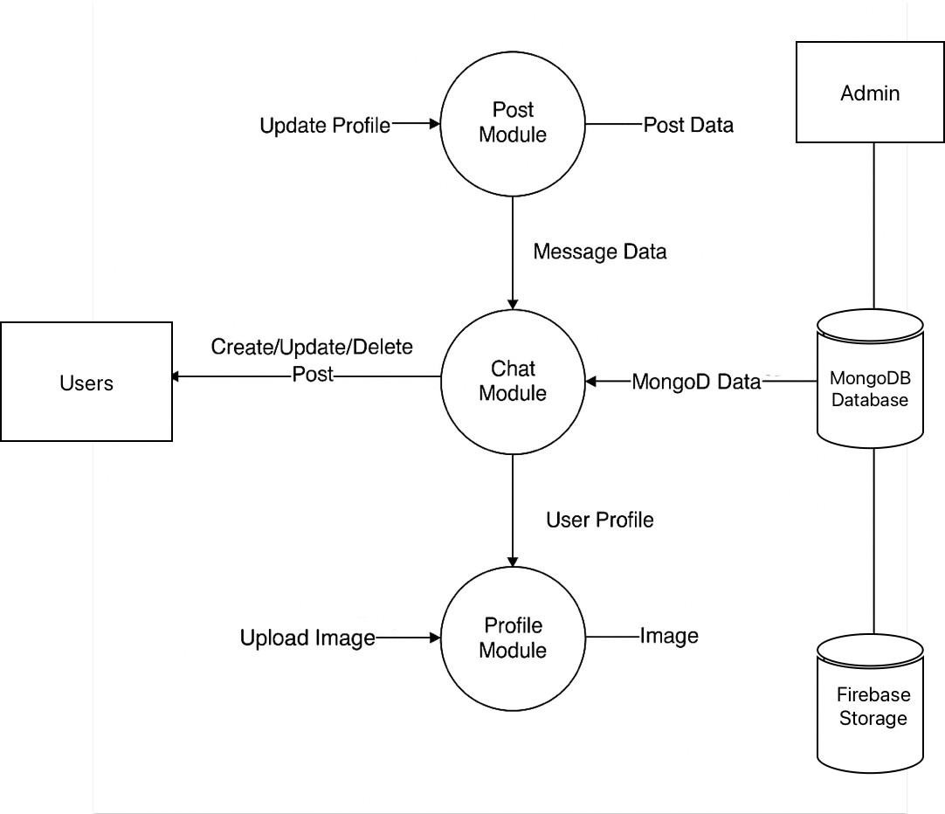

**User Stories – Socialex**

|  |  |  |  |  |  |
| --- | --- | --- | --- | --- | --- |
| **User Type** | **Functional Requirement (Epic)** | **User Story / Task** | **Acceptance Criteria** | **Priority** | **Release** |
| User | Profile Management | As a user, I can update my bio and profile picture. | Profile info is updated and saved. | High | Sprint-1 |
| User | Post Creation | As a user, I can create and share a new post. | Post appears on feed and profile. | High | Sprint-1 |
| User | Post Interaction | As a user, I can like and comment on posts. | Interaction updates in real-time. | Medium | Sprint-2 |
| User | Messaging | As a user, I can send and receive real-time messages. | Messages are delivered instantly. | High | Sprint-1 |
| User | Notifications | As a user, I receive notifications when others interact. | Notifications appear in bell icon. | Medium | Sprint-2 |
| Admin | User Moderation | As an admin, I can remove inappropriate content or ban users. | Action is logged and reflected immediately. | High | Sprint-2 |
| User | Search Users | As a user, I can search for other users by name or interest. | Relevant users appear in results. | Medium | Sprint-2 |
| User | Follow/Unfollow | As a user, I can follow or unfollow others. | Follower count updates correctly. | High | Sprint-1 |
| User | Media Upload | As a user, I can upload profile and post images. | Media is stored in Firebase and shown. | High | Sprint-1 |